E-commerce Order
Fulfillment & Delivery
Analytics



Submitted by:
Thiageshwaran S
ADMM
Technology And Transformation

March 2026
E-Commerce Order Fulfillment & Delivery Analytics
SAP ERP Integration with SQL Data Warehouse & Power BI
1. BUSINESS PROBLEM STATEMENT
1.1 Background
ShopX is a rapidly growing e-commerce enterprise operating across multiple regions with a diverse customer base. The company uses SAP ERP to manage core operational processes including:
- Sales Orders (Order Management System – OMS)
- Shipping and Logistics
- Inventory Management
- Customer Master Data
- Carrier/Vendor Management
While SAP ERP efficiently manages transactional workflows, it lacks advanced analytical capabilities required for performance monitoring, operational optimization, and executive-level reporting.
ShopX faced several operational challenges:
- Limited visibility into order processing delays
- Inability to measure warehouse fulfillment efficiency
- No structured tracking of SLA compliance
- Lack of consolidated KPI dashboards
- Poor carrier utilization visibility
- Difficulty identifying operational bottlenecks
To overcome these challenges, the company initiated a project to integrate SAP ERP data into a SQL-based Data Warehouse and develop analytical dashboards using Power BI.

1.2 Case Study Scope
The scope of this case study includes the design and implementation of an end-to-end analytics solution integrating SAP ERP data with a Data Warehouse and Business Intelligence layer.
The solution integrates the following components:
1.2.1 Order Management System (OMS)
Tracks orders from the moment they are placed by the customer until they are shipped.
1.2.2 Shipping & Delivery Analytics
Monitors logistics activities including shipment creation, shipping status, carrier allocation, and SLA compliance.
1.2.3 Customer Analytics
Analyze customer behavior, order frequency, operational impact, and segmentation-based performance.
1.3 Primary Objectives
The primary objective of this solution is to enable ShopX to track and optimize:
- Order processing times
- Fulfillment efficiency
- Shipment activity and load
- SLA compliance
- Operational bottlenecks
- Customer and sales segmentation insights
2. OBJECTIVES – KPIs AND GOALS
2.1 Key Performance Indicators (KPIs)
The following KPIs were designed and implemented:
2.1.1 Total Orders
Measures overall business demand.
2.1.2 Total Shipments
Measures operational execution volume.
2.1.3 Average Processing Time
Measures internal operational speed.
Processing Time = Shipment Date – Order Date
2.1.4 Fulfillment Efficiency (%)
Percentage of orders processed within SLA (≤ 2 days).
2.1.5 Processing SLA Compliance (%)
Percentage of shipments meeting internal processing standards.
2.1.6 On-Time Delivery Rate (%)
Measures shipment compliance against defined business rules.
2.1.7 Shipment per Order Ratio
Indicates operational complexity and order splitting behavior.
2.1.8 Average Items per Order
Measures basket size and order structure complexity.
2.2 Strategic Goals
The project aims to:
- Improve warehouse operational efficiency
- Reduce processing delays
- Monitor SLA compliance
- Optimize shipment allocation
- Analyze operational complexity
- Support executive decision-making
3. ETL PROCESS USING PYTHON AND SQL SERVER
A structured industry-standard ETL workflow was implemented using Python (Jupyter Notebook) and Microsoft SQL Server.
3.1 Extraction Phase
Tools Used
- Python (Pandas)
- Jupyter Notebook (VS Code)
- openpyxl
- SQLAlchemy
- pyodbc
Steps Performed
- Created structured project directory.
- Loaded Excel dataset using Pandas.
- Extracted the following sheets:
  - VBAK (Order Header)
  - VBAP (Order Items)
  - LIKP (Delivery Header)
  - LIPS (Delivery Items)
  - KNA1 (Customers)
  - LFA1 (Carriers)
  - VTTK (Shipment Header)
  - VTTP (Shipment Items)
- Conducted initial data inspection (shape, datatypes, preview).
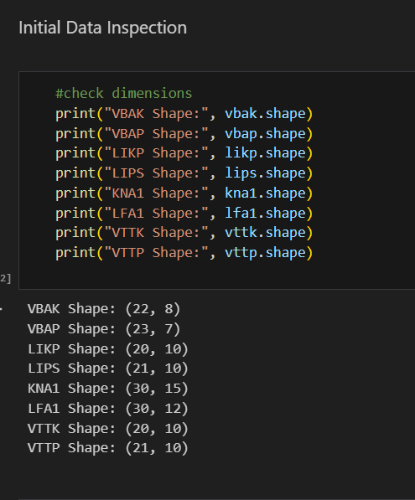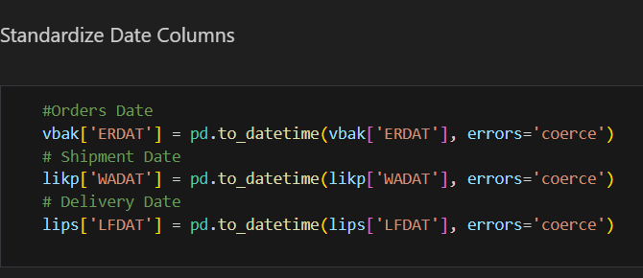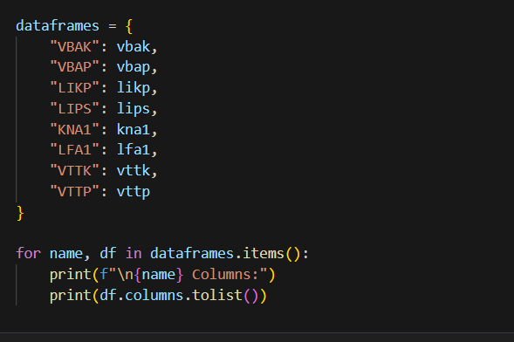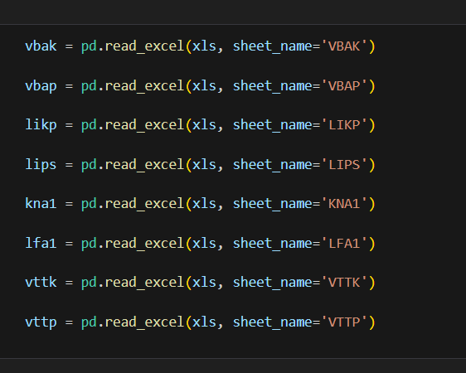
3.2 Data Validation
The following validations were performed:
- Missing key field checks
- Duplicate detection using composite keys
- Referential integrity checks
- Date validation and normalization
- Negative quantity and pricing checks
- Logical date sequence verification
Dataset Issue Identified
Delivery Date was equal to Shipment Date in the dataset.
This resulted in Delivery Time = 0, making the Average Delivery Time KPI analytically irrelevant.
Resolution
Average Delivery Time and related DAX measures were removed from the KPI layer and replaced with more meaningful operational metrics.
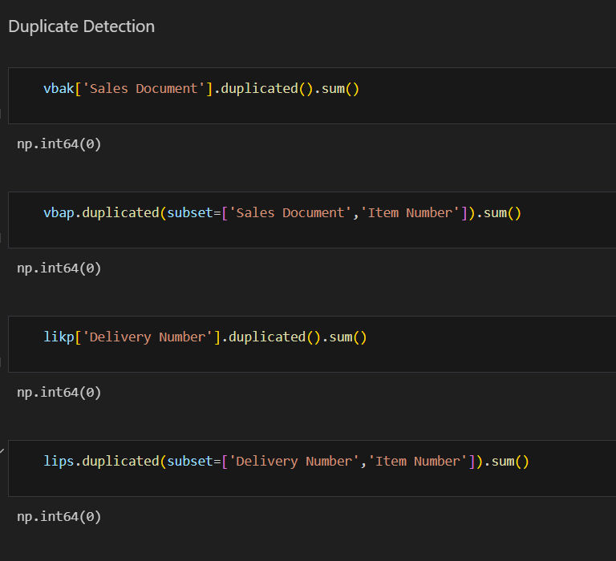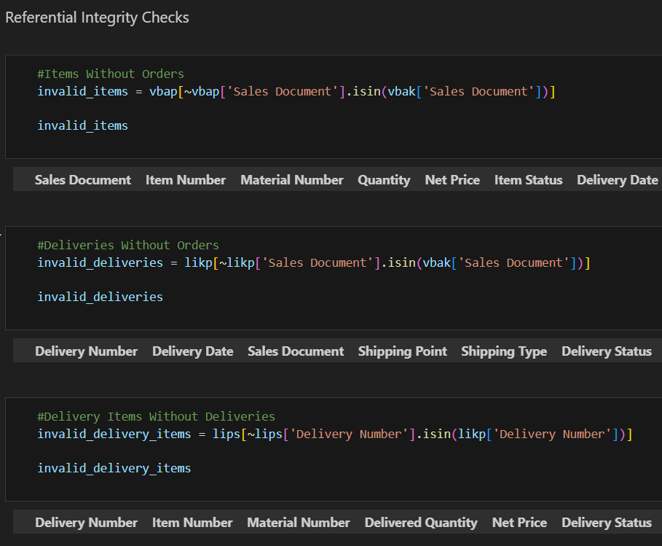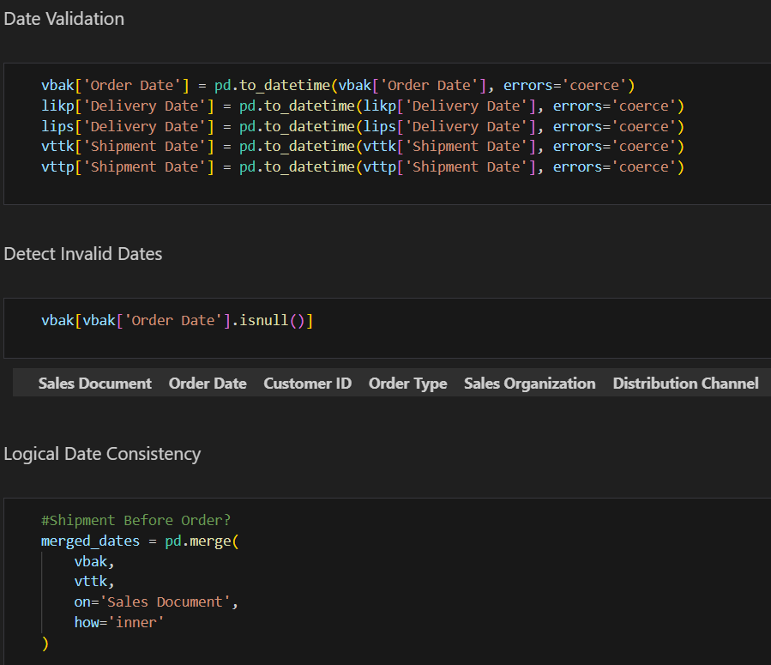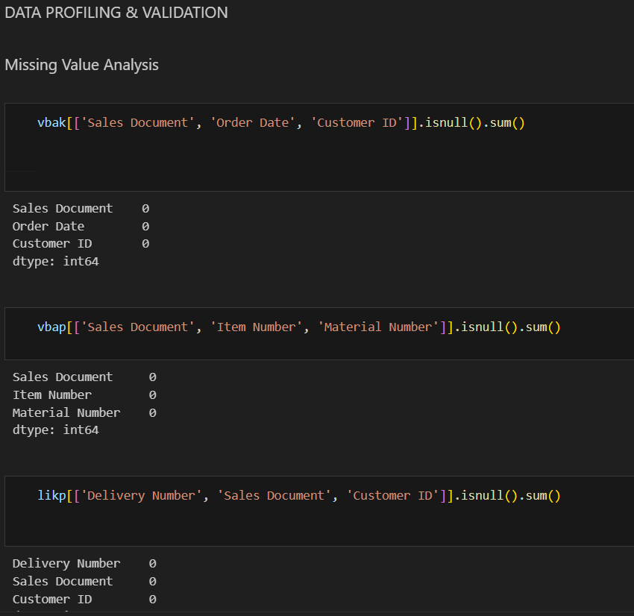
3.3 Transformation Phase
Raw SAP-style tables were transformed into business-friendly Data Warehouse tables.
S.No | Raw Table | Transformed Table
1 | VBAK | DW_Orders
2 | VBAP | DW_Order_Items
3 | KNA1 | DW_Customers
4 | LFA1 | DW_Carriers
5 | LIKP + VTTK | DW_Shipments
6 | LIPS + VTTP | DW_Shipment_Items

Standardization Applied
- Snake_case column naming
- Composite key preservation
- Duplicate removal
- Date normalization
- Business semantic clarity
- Removal of redundant fields
3.4 Loading into SQL Server
Using SQLAlchemy, transformed DataFrames were loaded into:
Database Name: ShopX_DW
SOURCE CODE:
CREATE DATABASE ShopX_DW;
use ShopX_DW;
SELECT COUNT(*) FROM DW_Orders;
SELECT COUNT(*) FROM DW_Order_Items;
SELECT COUNT(*) FROM DW_Customers;
SELECT COUNT(*) FROM DW_Shipments;

-- Order Processing Time
SELECT
o.order_id,
o.order_date,
s.shipment_number,
s.shipment_date,
DATEDIFF(DAY, o.order_date, s.shipment_date) AS processing_time_days
FROM DW_Orders o
JOIN DW_Shipments s
ON o.order_id = s.order_id;

-- Delivery Time
SELECT
s.shipment_number,
s.shipment_date,
si.delivery_date,
DATEDIFF(DAY, s.shipment_date, si.delivery_date) AS delivery_time_days
FROM DW_Shipments s
JOIN DW_Shipment_Items si
ON s.shipment_number = si.shipment_number;

-- Add On-Time Flag
SELECT
s.shipment_number,
DATEDIFF(DAY, s.shipment_date, si.delivery_date) AS delivery_time_days,
CASE
WHEN DATEDIFF(DAY, s.shipment_date, si.delivery_date) <= 3
THEN 'On-Time'
ELSE 'Delayed'
END AS on_time_flag
FROM DW_Shipments s
JOIN DW_Shipment_Items si
ON s.shipment_number = si.shipment_number;

-- Detect Negative or Illogical Cases
SELECT *
FROM DW_Shipments s
JOIN DW_Shipment_Items si
ON s.shipment_number = si.shipment_number
WHERE si.delivery_date < s.shipment_date;

-- Final Analytics Table
CREATE TABLE DW_Delivery_Analytics (
order_id VARCHAR(50),
shipment_number VARCHAR(50),
customer_id VARCHAR(50),
carrier_id VARCHAR(50),
order_date DATE,
shipment_date DATE,
delivery_date DATE,
processing_time_days INT,
delivery_time_days INT,
on_time_flag VARCHAR(20)
);

-- Insert Data

INSERT INTO DW_Delivery_Analytics
SELECT
o.order_id,
s.shipment_number,
o.customer_id,
s.carrier_id,
o.order_date,
s.shipment_date,
si.delivery_date,
DATEDIFF(DAY, o.order_date, s.shipment_date) AS processing_time_days,
DATEDIFF(DAY, s.shipment_date, si.delivery_date) AS delivery_time_days,
CASE
WHEN DATEDIFF(DAY, s.shipment_date, si.delivery_date) <= 3
THEN 'On-Time'
ELSE 'Delayed'
END AS on_time_flag
FROM DW_Orders o
JOIN DW_Shipments s
ON o.order_id = s.order_id
JOIN DW_Shipment_Items si
ON s.shipment_number = si.shipment_number;

-- Aggregate KPIs

--Average Processing Time
SELECT AVG(processing_time_days) AS avg_processing_time
FROM DW_Delivery_Analytics;

-- Average Delivery Time
SELECT AVG(delivery_time_days) AS avg_delivery_time
FROM DW_Delivery_Analytics;

-- On-Time Delivery Rate
SELECT
CAST(
SUM(CASE WHEN on_time_flag = 'On-Time' THEN 1 ELSE 0 END)
* 100.0 / COUNT(*)
AS DECIMAL(5,2)) AS on_time_delivery_rate_percent
FROM DW_Delivery_Analytics;

-- Carrier Performance
SELECT
carrier_id,
AVG(delivery_time_days) AS avg_delivery_time,
COUNT(*) AS total_shipments
FROM DW_Delivery_Analytics
GROUP BY carrier_id
ORDER BY avg_delivery_time;

-- SQL to Calculate Efficiency Per Order
SELECT
order_id,
processing_time_days,
CASE
WHEN processing_time_days <= 2
THEN 'Efficient'
ELSE 'Delayed Processing'
END AS fulfillment_status
FROM DW_Delivery_Analytics;

-- Calculate Fulfillment Efficiency %
SELECT
CAST(
SUM(CASE WHEN processing_time_days <= 2 THEN 1 ELSE 0 END)
* 100.0 / COUNT(*)
AS DECIMAL(5,2))
AS fulfillment_efficiency_percent
FROM DW_Delivery_Analytics;

-- Fulfillment Efficiency by Month
SELECT
FORMAT(order_date, 'yyyy-MM') AS order_month,
CAST(
SUM(CASE WHEN processing_time_days <= 2 THEN 1 ELSE 0 END)
* 100.0 / COUNT(*)
AS DECIMAL(5,2))
AS fulfillment_efficiency_percent
FROM DW_Delivery_Analytics
GROUP BY FORMAT(order_date, 'yyyy-MM')
ORDER BY order_month;

-- Fulfillment Efficiency by Shipping Point

SELECT
s.shipping_point,
CAST(
SUM(CASE WHEN a.processing_time_days <= 2 THEN 1 ELSE 0 END)
* 100.0 / COUNT(*)
AS DECIMAL(5,2))
AS fulfillment_efficiency_percent
FROM DW_Delivery_Analytics a
JOIN DW_Shipments s
ON a.shipment_number = s.shipment_number
GROUP BY s.shipping_point
ORDER BY fulfillment_efficiency_percent DESC;
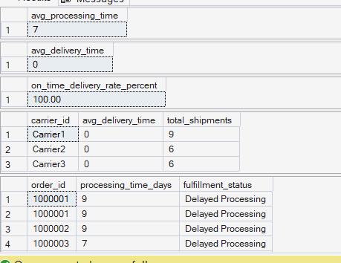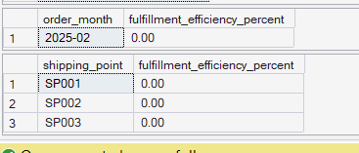
Tables created:
- DW_Customers
- DW_Orders
- DW_Order_Items
- DW_Shipments
- DW_Shipment_Items
- DW_Carriers
- DW_Delivery_Analytics
Row count validations were performed post-load to ensure data integrity.
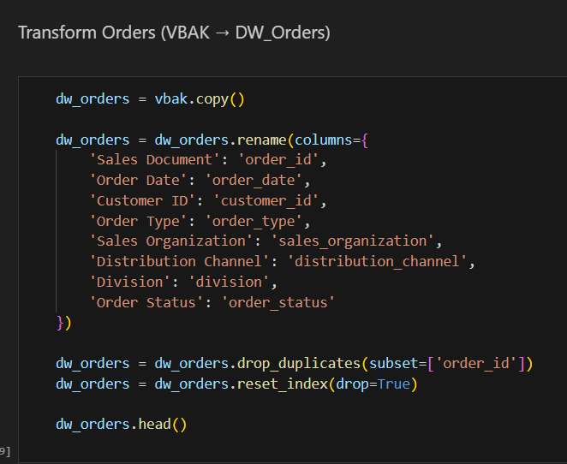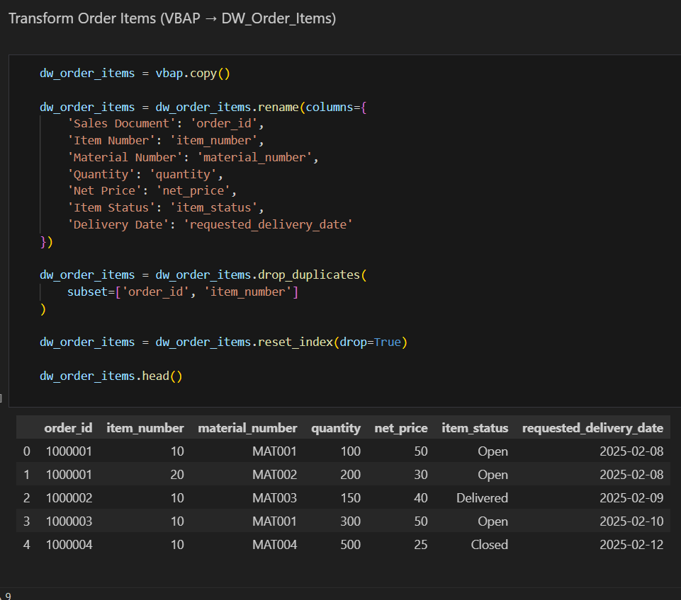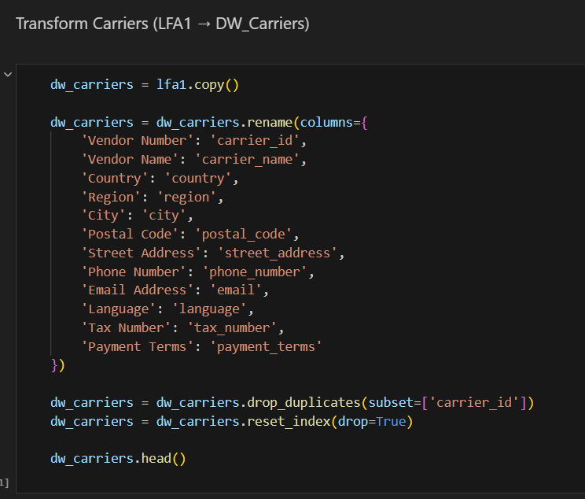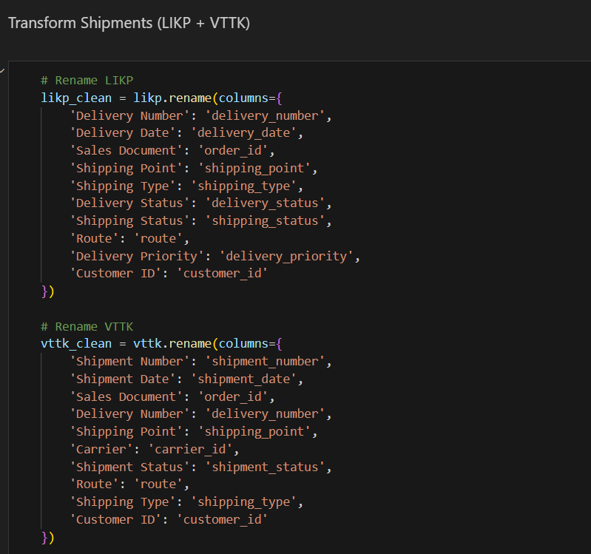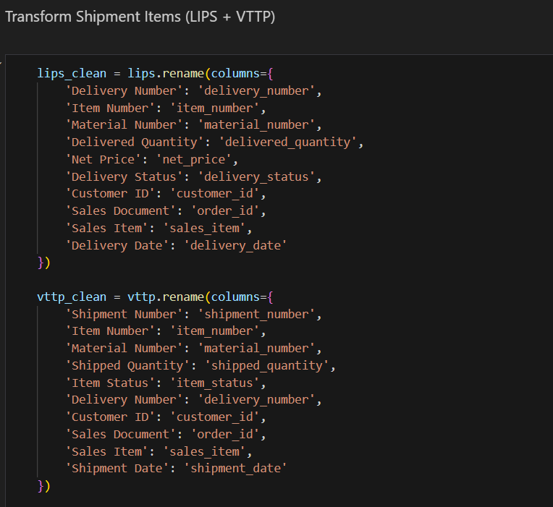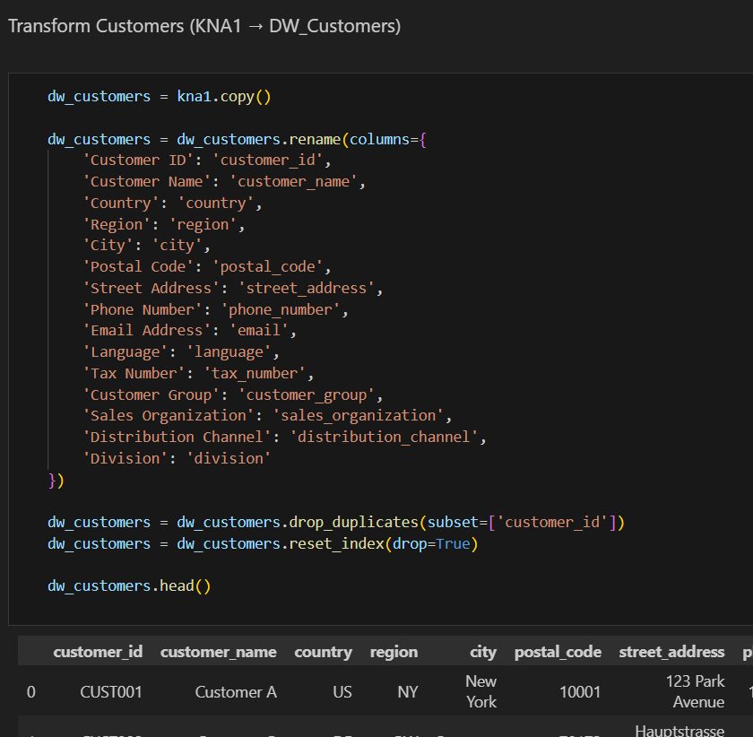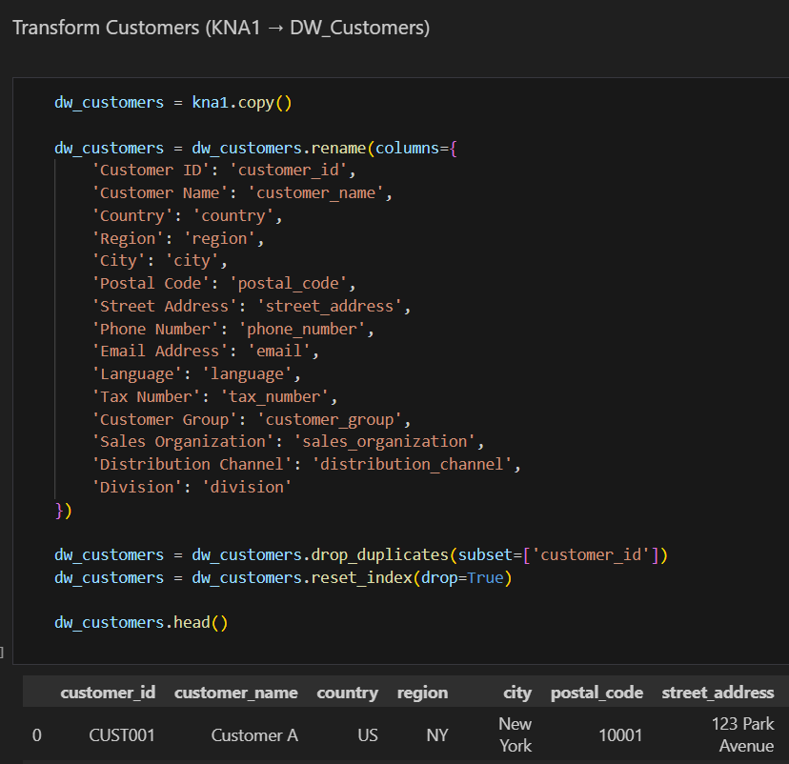
4. EXPLORATORY DATA ANALYSIS (EDA) AND DATA WAREHOUSE DESIGN
4.1 Exploratory Data Analysis
EDA was conducted in two layers:
4.1.1 Structural EDA
- Row count verification
- Key uniqueness checks
- Referential validation
- Null value analysis
4.1.2 Business EDA
- Orders per customer analysis
- Items per order distribution
- Shipment per order analysis
- Carrier utilization distribution
- Processing time distribution
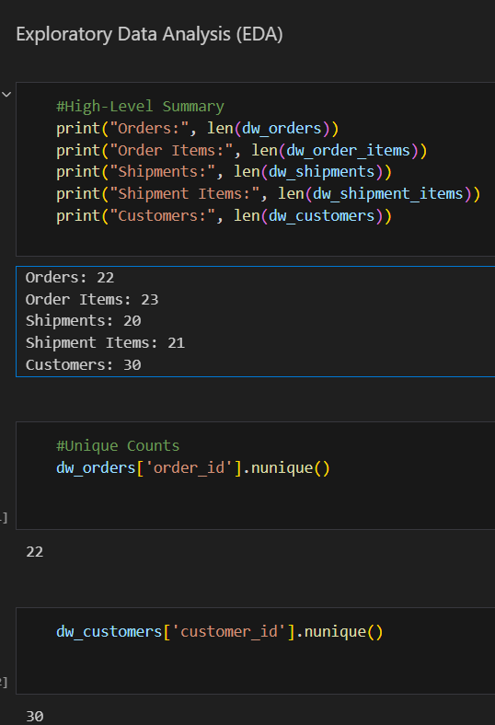
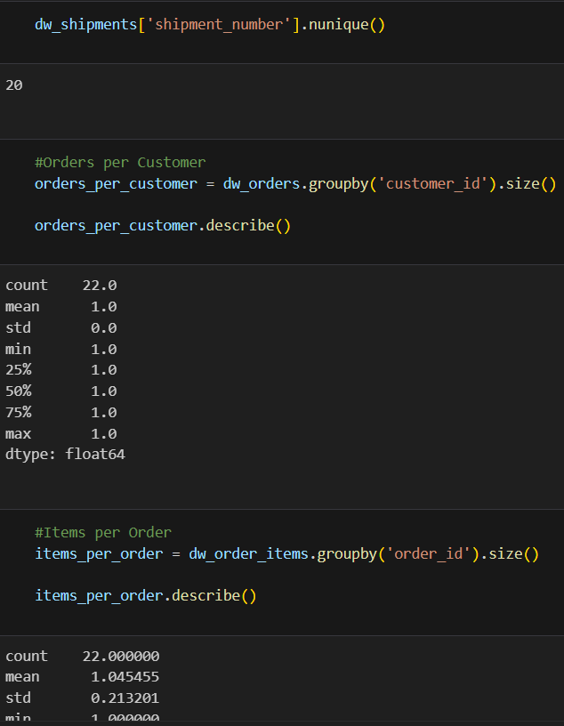
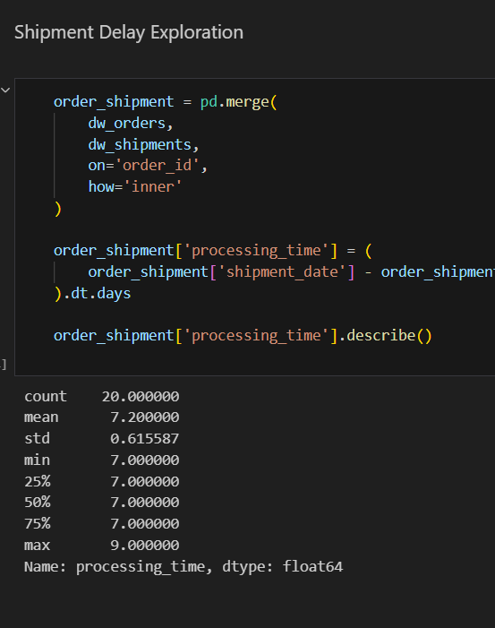
4.2 Staging Layer Implementation
Raw data was first loaded into staging tables (STG_* tables).
Purpose:
- Preserve original source data
- Enable auditability
- Ensure rollback capability
- Improve data reliability
LOADING PHASE:
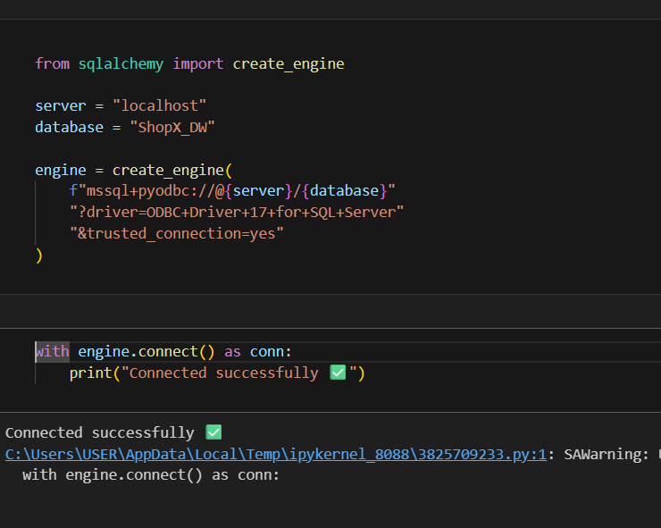
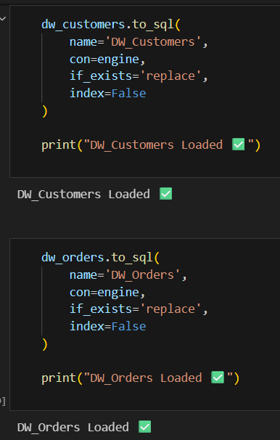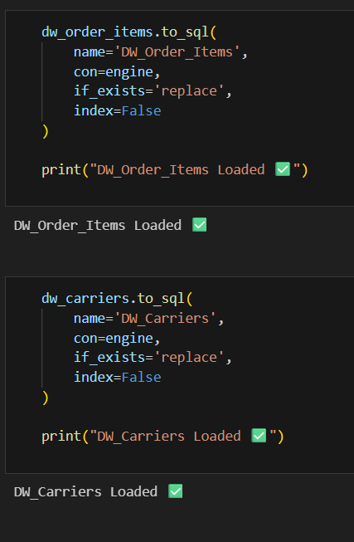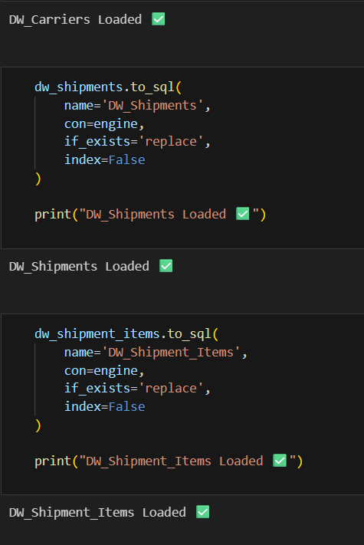
4.3 Data Warehouse Design – Star Schema
A star schema architecture was implemented.
Fact Tables
- DW_Delivery_Analytics
- DW_Shipment_Items
- DW_Order_Items
Dimension Tables
- DW_Customers
- DW_Carriers
- DW_Orders
- DW_Shipments
Benefits
- Improved query performance
- Simplified Power BI modeling
- Reduced complexity
- Enhanced KPI calculation efficiency
5. POWER BI IMPLEMENTATION
5.1 Data Modeling
Relationships established:
- Orders → Customers
- Orders → Shipments
- Shipments → Shipment Items
- Orders → Delivery Analytics
- Carriers → Shipments
Cardinality and filter directions were carefully configured to avoid circular dependencies.
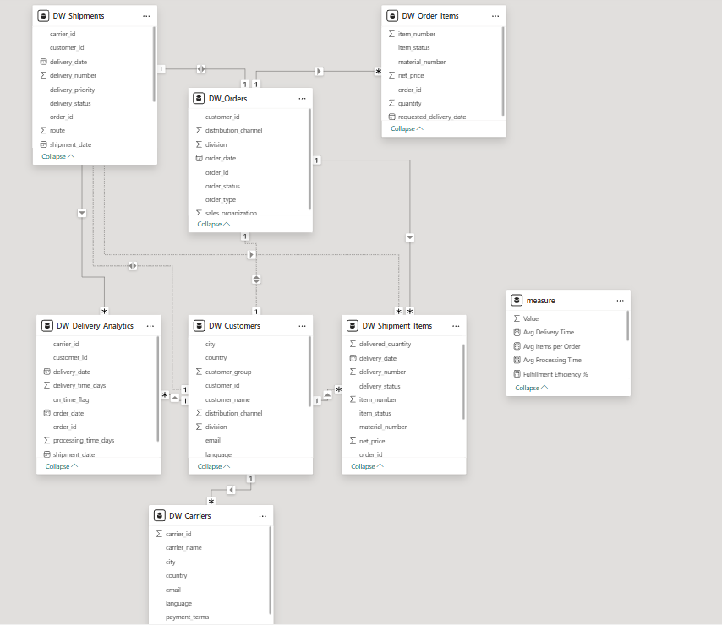
5.2 KPI Measures (DAX)
Key DAX Measures Created:
- Total Orders
- Total Shipments
- Fulfillment Efficiency %
- Processing SLA %
- Shipment per Order Ratio
- Avg Processing Time
- Avg Items per Order
- On-Time Delivery Rate %
- Processing Delays
- Orders with Multiple Shipments
5.3 Data Cleaning in Power BI
- Corrected data types
- Standardized percentage formats
- Removed unused columns
- Verified measure logic
- Validated aggregation behavior
5.4 Dashboard Development
Page 1 – Executive Overview
High-level operational snapshot.
Page 2 – Fulfillment & Processing Analysis
Warehouse efficiency and SLA compliance.
Page 3 – Order Complexity & Operational Structure
Order splitting and basket analysis.
Page 4 – Customer & Sales Insights
Customer segmentation and regional performance.
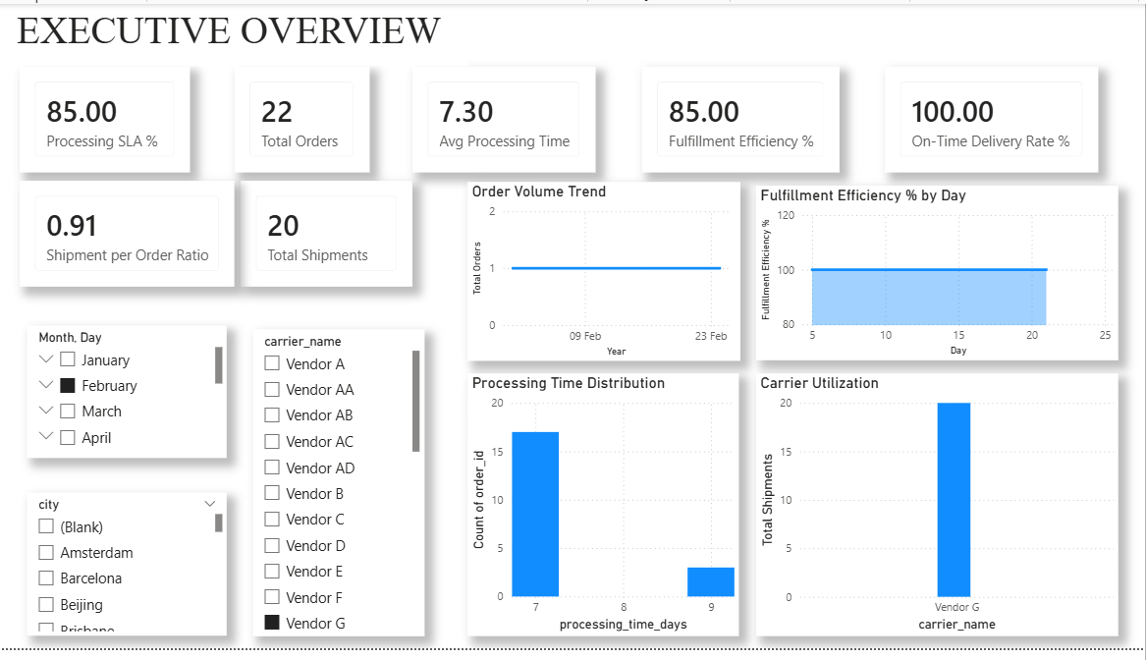

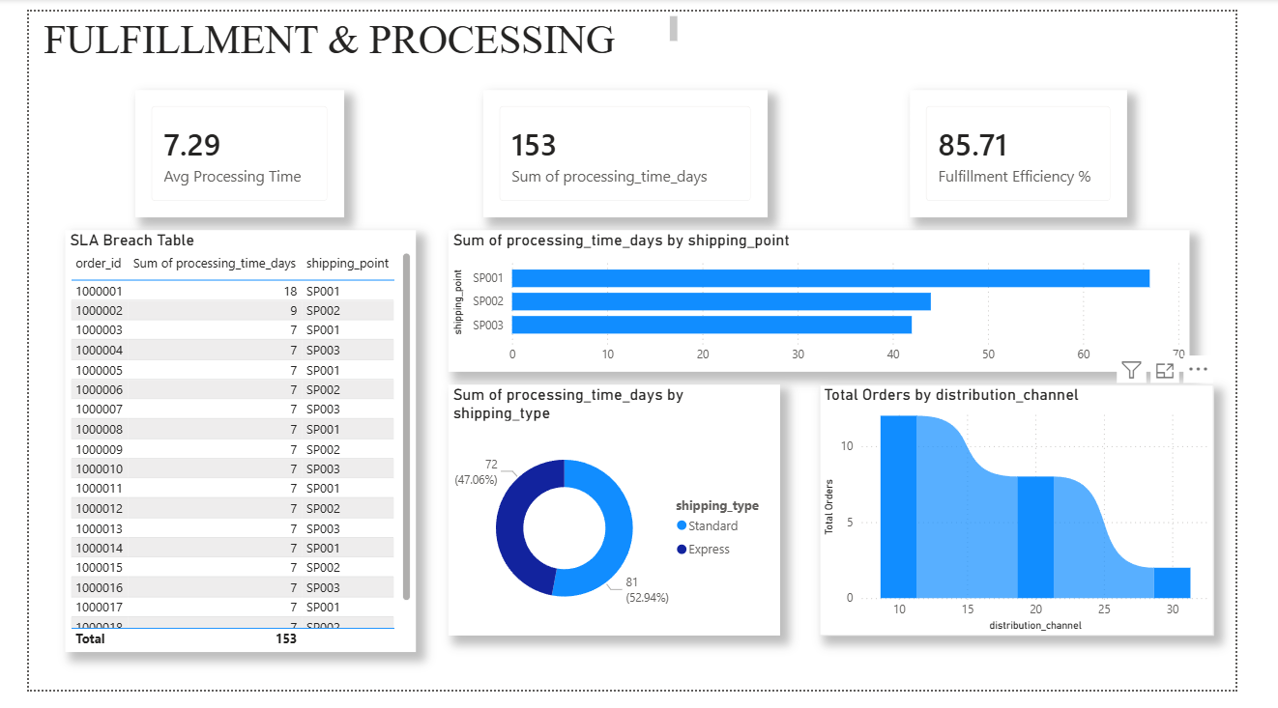
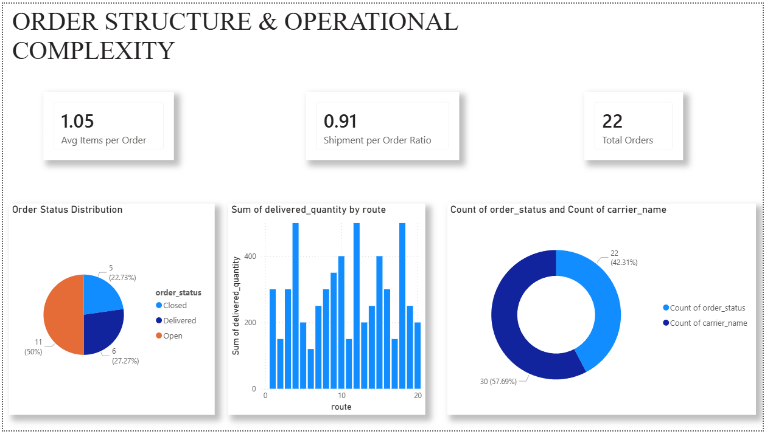
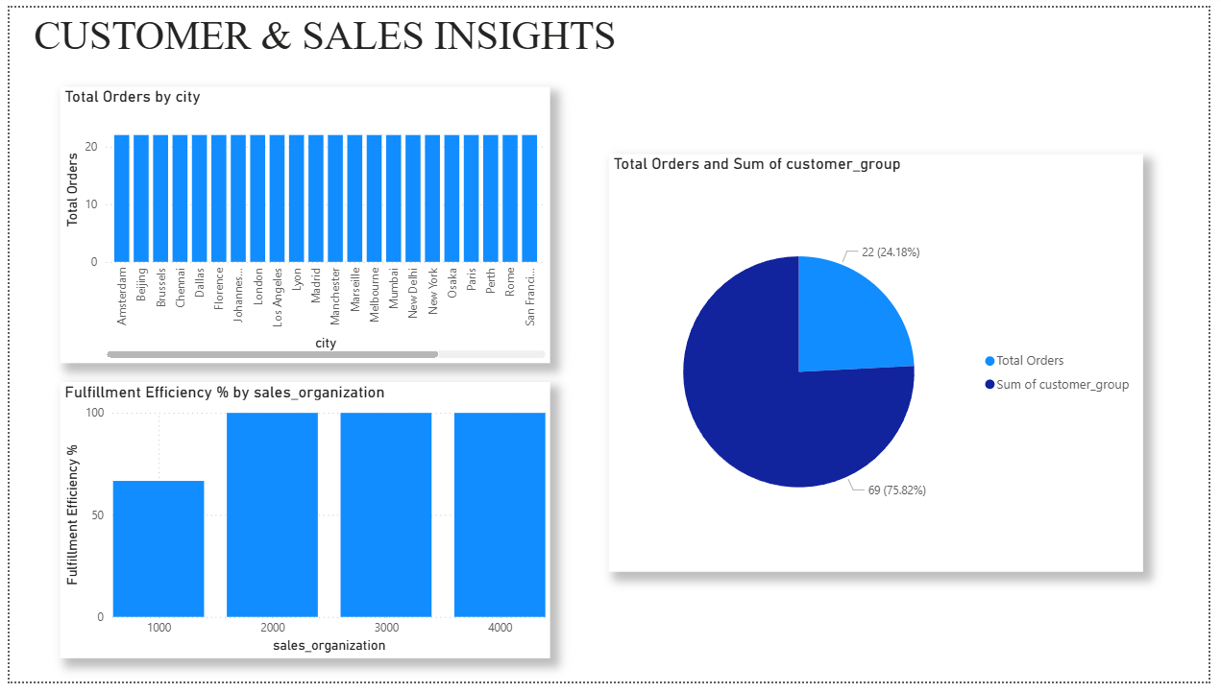
6. DATASET CHALLENGES AND RESOLUTIONS
S.No | Challenge | Impact | Resolution
1 | Delivery Date = Shipment Date | Zero delivery duration | Removed Avg Delivery Time KPI
2 | Duplicate composite keys | Double counting | Applied composite validation
3 | Date columns as object type | Incorrect calculations | Converted to datetime
4 | Multiple shipments per order | KPI distortion | Introduced Shipment per Order Ratio
5 | Missing foreign key references | Broken joins | Performed referential validation
6 | Inconsistent naming | Modeling confusion | Standardized naming convention

7. PROJECT OUTCOME
The final solution delivered:
- Automated ETL pipeline using Python
- Structured SQL Server Data Warehouse
- Star schema data model
- Business-ready KPI layer
- 4-page executive Power BI dashboard
- Operational intelligence framework
The solution enables ShopX to:
- Monitor fulfillment performance
- Track SLA compliance
- Analyze operational complexity
- Optimize carrier utilization
- Improve data-driven decision making
8. CONCLUSION
The solution bridges the gap between SAP transactional data and strategic analytics, enabling improved operational transparency and performance optimization.

